Bringing Forward God’s Tithes and Our Gifts
*Doxology # 95 Praise God from whom all blessings flow; praise him, all Creatures here below; praise him above, ye heavenly host; praise Father, Son, and Holy Ghost. Amen.
*Prayer of Thanksgiving
Sharing of Joys and Concerns
The Lord’s Prayer

Our Father, who art in heaven, hallowed be thy name. Thy kingdom come, Thy will be done on earth as it is in heaven. Give us this day our daily bread and forgive us our trespasses, as we forgive those who trespass against us. And lead us not into temptation, but deliver us from evil. For thine is the kingdom, and the power, and the glory, forever. Amen.
*Singing Our Faith # 176 “Majesty, Worship His Majesty”
*Blessing and Dismissal
*Postlude

Scatter to Serve God & Neighbor

Welcome to all! We gather to praise God for the innumerable blessings given to us and to grow deeper in the Spirit. Joyfully, let us lift our hearts to God.

DIRECTORY OF CHESTNUT HILL UNITED METHODIST CHURCH
Sue Haupert-Johnson |  | Richmond Area Resident Bishop
 | Denise Bates |  | Mountain View District Superintendent
 | Adam White |  | Minister
 | Erin Long |  | Associate Minister
 | Monica Campbell |  | Administrative Assistant
 | Heather Wilson |  | Director of Music Ministry
 | Judy Martin |  | Bookkeeper
 | Judy Robertson  Elizabeth Nichols |  | Lay Leader  Missionary in Henry County

C hestnut Hill
United Methodist Church

Making disciples of Jesus Christ
for the transformation of the world.
You are welcome at Chestnut Hill UMC.

4660 Fort Avenue ~ Lynchburg, Virginia 24502
Church: 434-239-8423
Minister’s Cell: 434-944-7723, Minister’s Email: awhite@ves.org
Associate Minister’s Cell: 1-502-489-0200
Associate Minister’s Email: healingsolutions12@gmail.com
Email: chestnuthillumc@comcast.net
On the Web at chestnuthillumc.net
Find us on Facebook: Chestnut Hill United Methodist Church

Chestnut Hill United Methodist Church
10:30 a.m. ~ April 28, 2024 ~ Fifth Sunday of Easter
Our ministry vision for the Virginia Annual Conference is “to be disciples of Jesus Christ who are lifelong learners, who influence others to serve.”

Welcome! Join us in worshiping God!

Prelude
Welcome and Ministry Announcements
Welcome in the name of Christ our Lord. Please register your attendance, printing your name, address, phone, and email, on the attendance pad provided on your pew. Thank you for silencing cell phones as we gather to worship God.
Invocation
*Greeting
My heart is hungry, my spirit doth thirst;
I come to Thee, Lord, to seek Thy supply;
All that I need is none other but Thee,
Thou canst my hunger and thirst satisfy.
Thou art the food and the water of life,
Thou canst revive me, my spirit upbear;
I long to eat and to drink here of Thee,
Thyself enjoy through my reading and prayer.
Thou in the Word art the Spirit and life,
Thus by the Word I may feed upon Thee;
Thou dost as Spirit in my spirit live,
Thus I may drink in the spirit of Thee.
Now to enjoy Thee I come to Thy Word,
On Thee to feed till my hunger is o’er.
Now in my spirit I turn unto Thee,
Of Thee to drink till I’m thirsty no more.

Feeding and drinking, Lord Jesus, of Thee,
Feeding by reading, and drinking by prayer;
Reading and praying, I eat and I drink,
Praying and reading—Lord, Thou art my fare.
Here, O my Lord, may I feast upon Thee;
Flood with Thy Spirit and fill by Thy Word;
May, Lord, Thou be such a feast unto me
As man hath never enjoyed nor e’er heard.
*Singing Our Faith # 370 “Victory in Jesus”

Opening Prayer
O God, whose blessed Son made himself known to his disciples in the breaking of bread: Open the eyes of our faith, that we may behold him in all his redeeming work; who lives and reigns with you, in the unity of the Holy Spirit, one God, now and for ever. Amen.

Anthem “He Touched Me”

Greeting Friends and Neighbors
Prayer for Illumination
Almighty God, through your only Son you overcame death and opened to us the light of eternity. Enlighten our minds and kindle our hearts with the presence of your Spirit, that we may hear your words of comfort and challenge in the reading of the scriptures, through Jesus Christ our Lord. Amen.
Scripture Lesson Luke 24:36b-48
The Word of God for the people of God.

Thanks be to God.
Singing Our Faith # 170 “O How I Love Jesus”
The Good News “See Food”

**Calendar **
Friday, 5/3 | 10:00 a.m. | Homeschool
Saturday, 5/4 | 12:00 p.m. | Homeschool Festival of the Arts
**Looking Ahead on the Calendar **
Thursday, 5/9 | 1:00 p.m. | Peaks View Clergy Lunch & Learn

Hospital: Duke University Hospital (NC): Steven Short

For the Grocery Cart: April and May
Pop-top cans of meats, soups, pasta dishes, and vegetables, body wash, shampoo, and deodorant. Place donations in the grocery cart, located in the Commons.
Cards for Homebound Members
Please take a moment to sign the cards for our homebound members/friends that Erin has placed in the Commons.

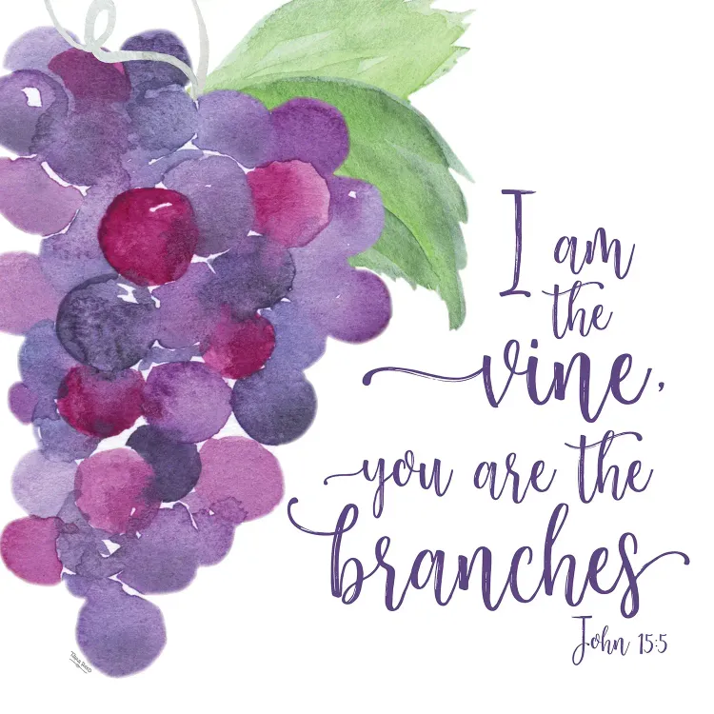

**Calendar **
Friday, 5/3 | 10:00 a.m. | Homeschool
Saturday, 5/4 | 12:00 p.m. | Homeschool Festival of the Arts
**Looking Ahead on the Calendar **
Thursday, 5/9 | 1:00 p.m. | Peaks View Clergy Lunch & Learn

Hospital: Duke University Hospital (NC): Steven Short

For the Grocery Cart: April and May
Pop-top cans of meats, soups, pasta dishes, and vegetables, body wash, shampoo, and deodorant. Place donations in the grocery cart, located in the Commons.
Cards for Homebound Members
Please take a moment to sign the cards for our homebound members/friends that Erin has placed in the Commons.

